Research Title
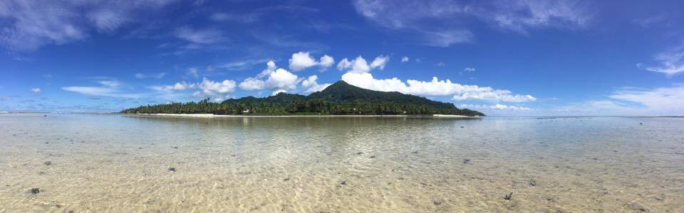
Prepared for: FSM Office of National Archives, Culture and Historic Preservation
Prepared by: Name, Job Title
March 14, 2019
Proposal number: 123-4567

Table of Contents

Research Title 1
A. Proposal 3
I. Introduction 3
II. Problem/Objectives 3
III. Significance of the Study 3
IV. Time Table 3
V. Methodology and Methods 3
VI. Results 3
VII. Impacts of Research on Communities 3
VIII. References 3
IX. Appendices 3
B. Budget 4
Narrative 4

A. Proposal

The purpose of this proposal is to inform on the nature of the proposed research. Please fill out this form and attach it to the research proposal from your respective institution along with any approvals already secured.

I. Introduction
Include an introduction to the problem and literature review on the subject.

II. Problem/Objectives
Identify the research questions here.

III. Significance of the Study
Indicate the importance of this study and provide substantial justification for the study.

IV. Time Table
Indicate the time frame for the whole project and the time needed to carry out the research work components in the communities.

V. Methodology and Methods
Explain the method(s) and why they are most appropriate for research in the Federated States of Micronesia.

VI. Results
Describe the results anticipated.

VII. Impacts of Research on Communities
Describe here the potential socio-cultural, environmental, and/or other impacts on communities involved that may result from this project.

VIII. References
Please provide a list of references cited and consulted in the preparation of the research project.

IX. Appendices
This should include any attachments for the proposal, including but not limited to, permissions secured at home institution, informed consent, letters of support, etc.

B. Budget

Narrative
Please describe here who will be needed from the community and economic impact.

Description | Quantity | Unit Price | Cost
Item 1 | 1 | $‎ 1 | $‎ 1
Item 2 | 2 | $‎ 2 | $‎ 4
Item 3 | 3 | $‎ 3 | $‎ 9
 |  | $‎ 0 | $‎ 0
Total |  | $0 | $‎ 14

